**Character and Set Design Couse Work 1 Report**

**Introduction**

In this report I will be detail my entire design and modelling process for the robotic athlete. This will include the design pipeline, working and adapting from inspiration, the modelling techniques used, and justification to sing a wide variety of techniques that Maya has to offer.

**Pre-Production and Planning**

To begin with I created a style sheet and mood board in order to get inspiration and ideas about what I could use for my robot model (seen in appendix). I used pictures of robots from films such as *Real Steel*, *iRobot,* and *Star Wars*, along with some examples of real-life robots from companies such as Boston Dynamics. Along with these, I also added pictures of human Olympians in order to get ideas for both the types of movements the Robotic Olympoid should be able to perform, as well as ideas for real-world objects that could be modelled alongside the main robot as either props/items or as part of the Olympoid itself.

Initially I thought of a one-armed Robot with wheels as its way of movement. The idea behind the single arm was that the arm could be revolved at speed to enable good throwing performance by using centrifugal forces to its advantage. Utilising wheels would differentiate the robot from looking like a total human copy, something I didn’t want, as well as giving it good performance in track events.  
These factors changed however into a more traditional, human styled design with two arms and two legs. This was mainly for the fact that I preferred the look of two arms from my development sketches, plus the robot would be able to (theoretically) be able to perform well in a wider variety of sports with two arms (archery for example would be much harder with just one arm).  
I chose to replace the wheels with Para-Olympian prosthetic blades, as again I felt that these would provide more versatility in the sports that the Olympoid could compete in. Additionally, I felt that the blades fitted the design of my Olympoid much better than one with wheels.

After having done some development drawings, and playing with different ideas for the Olympoid, I settled on the features I wanted and began my final sketches and blueprints for the Robot. Blueprints from multiple angles allowed me to import these into Maya and model accurately from them. I chose to sketch out each body parts separately so that I could more accurately draw the different viewpoints needed to model from.

From the beginning I wanted my robot to have some sort of curved shape to it, to give a more interesting look. This was also coupled with the fact that in events such as running or swimming, aerodynamics will play a big part into how well the competitor can perform. Therefore, having an aerodynamic bevel on the front of the Olympoid’s body will be able to cut through the air or water to reduce resistance, akin to that of a human nose.

The style of the arms came from various images found in the style sheet. The shoulder and upper arm was inspired from the T-800 Terminator, having a exoskeleton of sorts and exposed wiring and hydraulics. The lower arm was based off a Real Steel fighting robot, and Sonny from iRobot, as well as the claw from the Boston Dynamic’s robot pictured in the appendix.

Inspiration for the leg can be seen from the artificial muscles that Sonny has in iRobot, as I liked the idea of mimicking a human’s mechanics in a robot. The lower leg uses a Para-Olympian’s prosthetic blade as mentioned above due to its versatility in many events, whilst also having a unique look to it compared to a traditional lower leg shape.

Finally, the head was inspired by BB-8 from Star Wars. The ability to look in 360 degrees, coupled with the non-human styled head appealed to me. I also felt that making the head irregular compared to a human head would add individuality to the design.

The decision to not draw top viewpoints for the arm and legs was made since the geometry for these would be very simple from this angle because of the spherical geometry of the shoulder pads and hip connector. Therefore, inferring how these parts should look would be easily achievable whilst modelling in Maya.

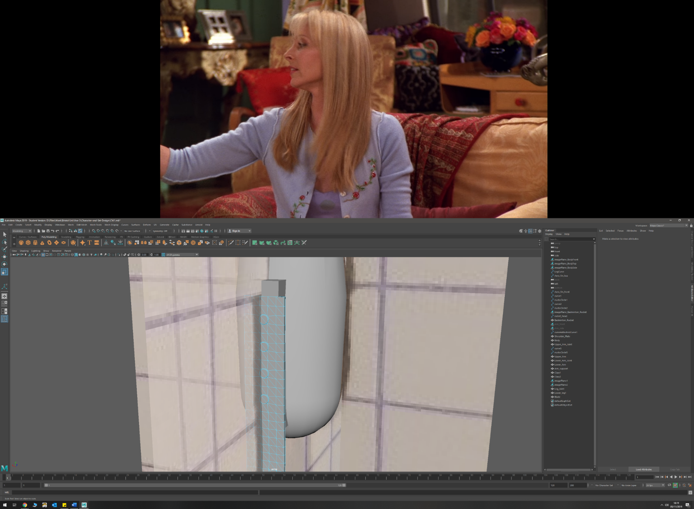**Techniques and Surfaces**

* Circularize
  + Camera on head
  + Screws on blade mount
  + Shoulder joint
* Primitive up modelling
  + Body
  + Leg (upper and lower)
  + Forearm
  + Badminton racket handle

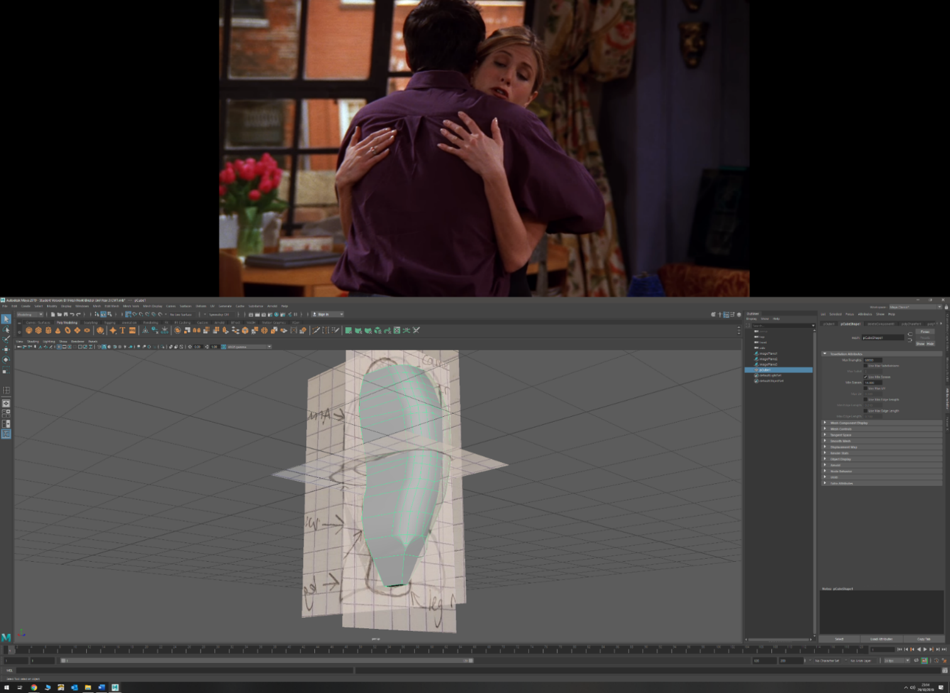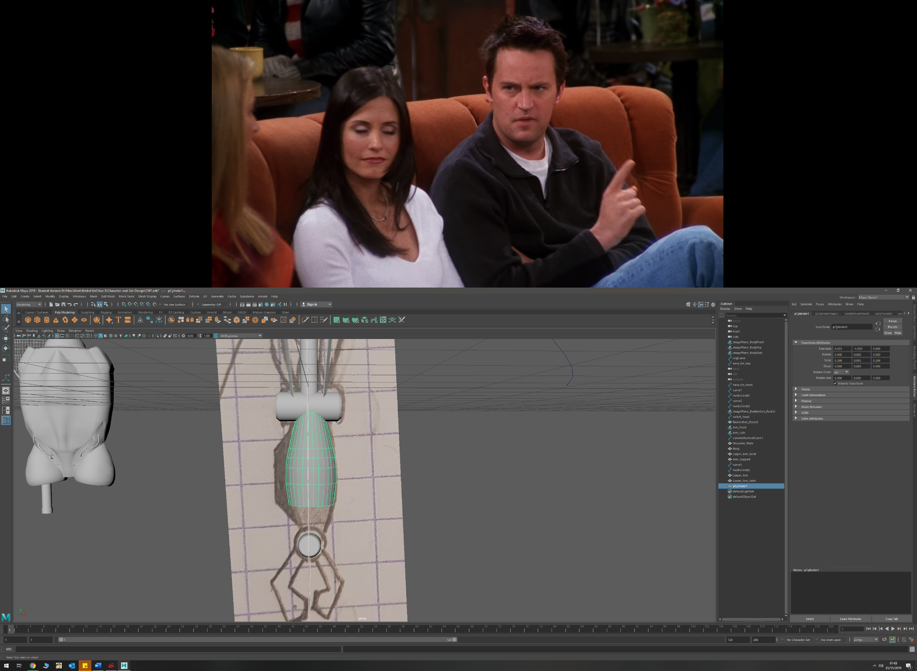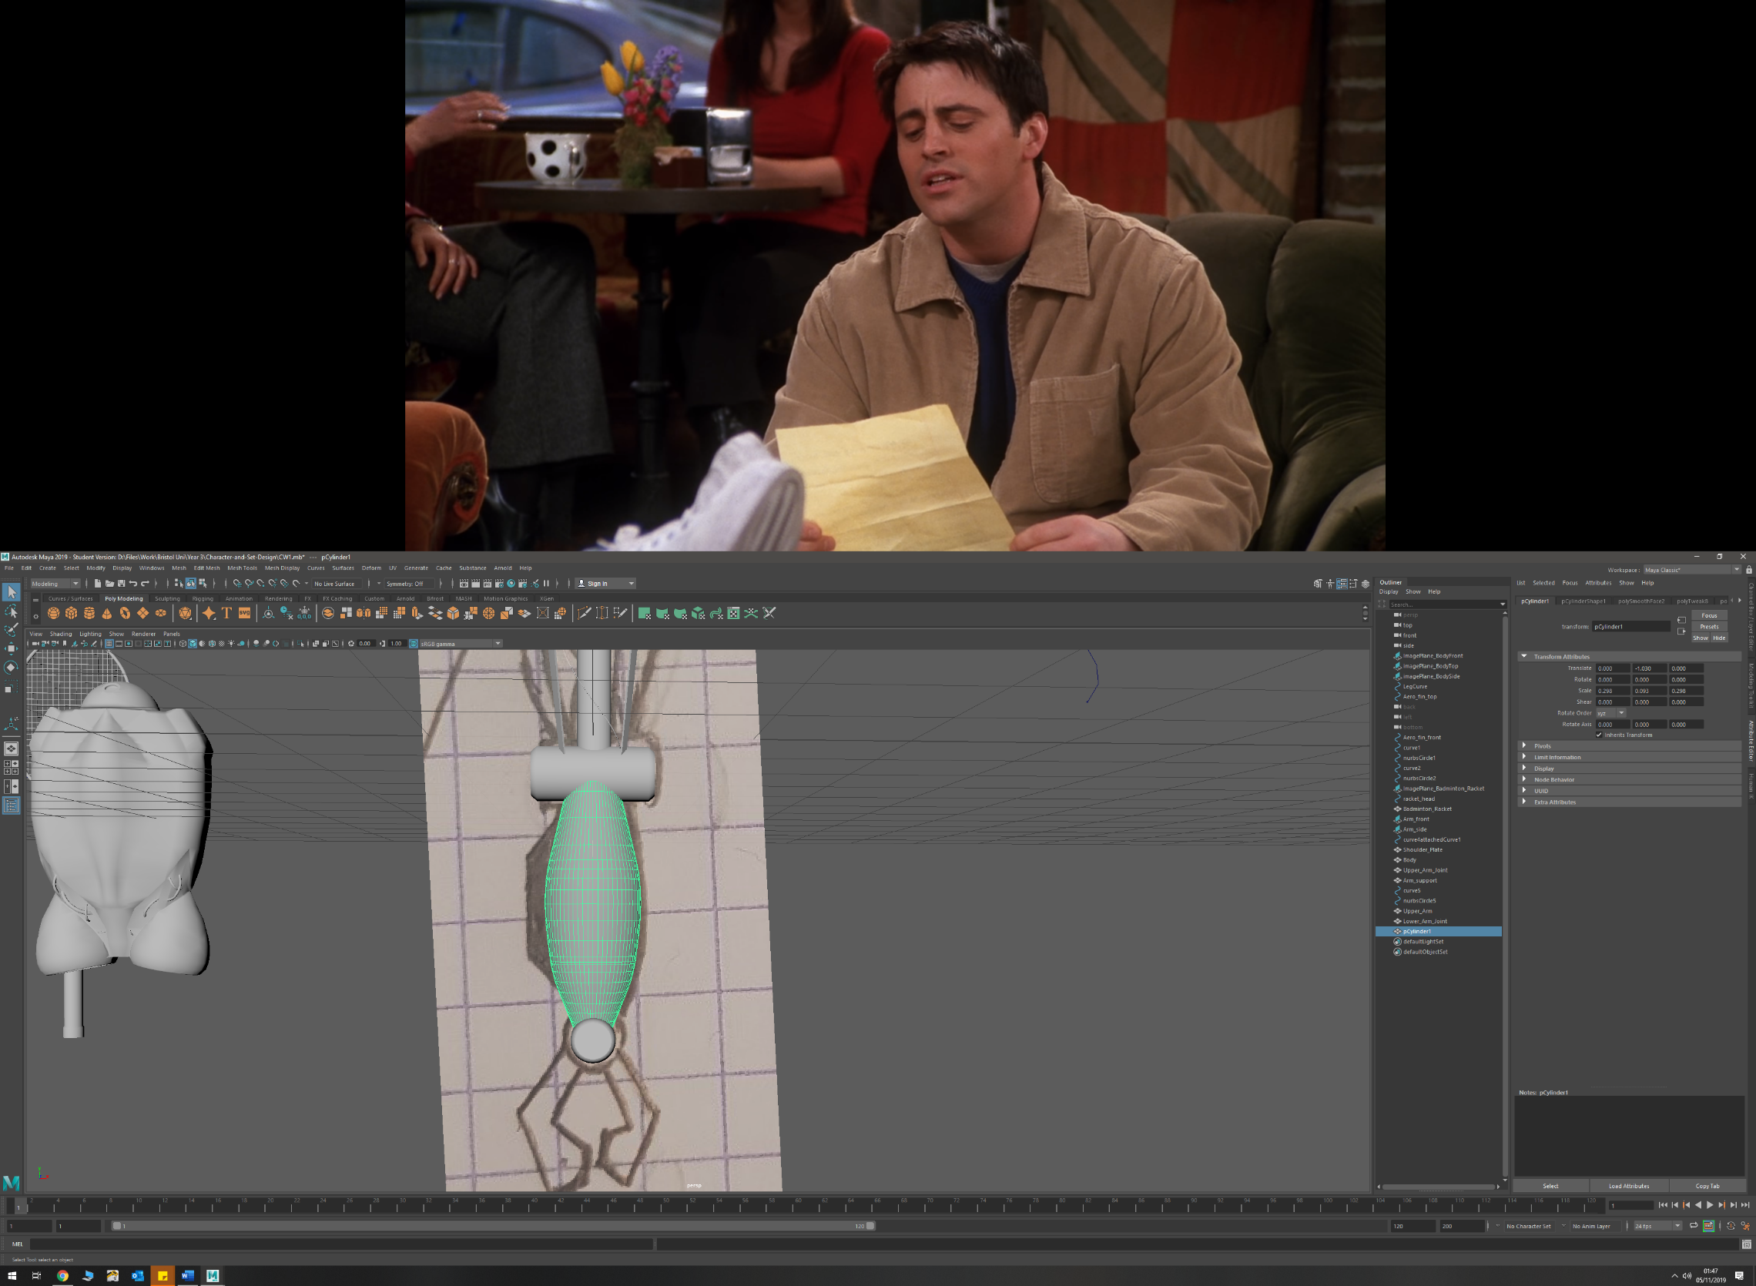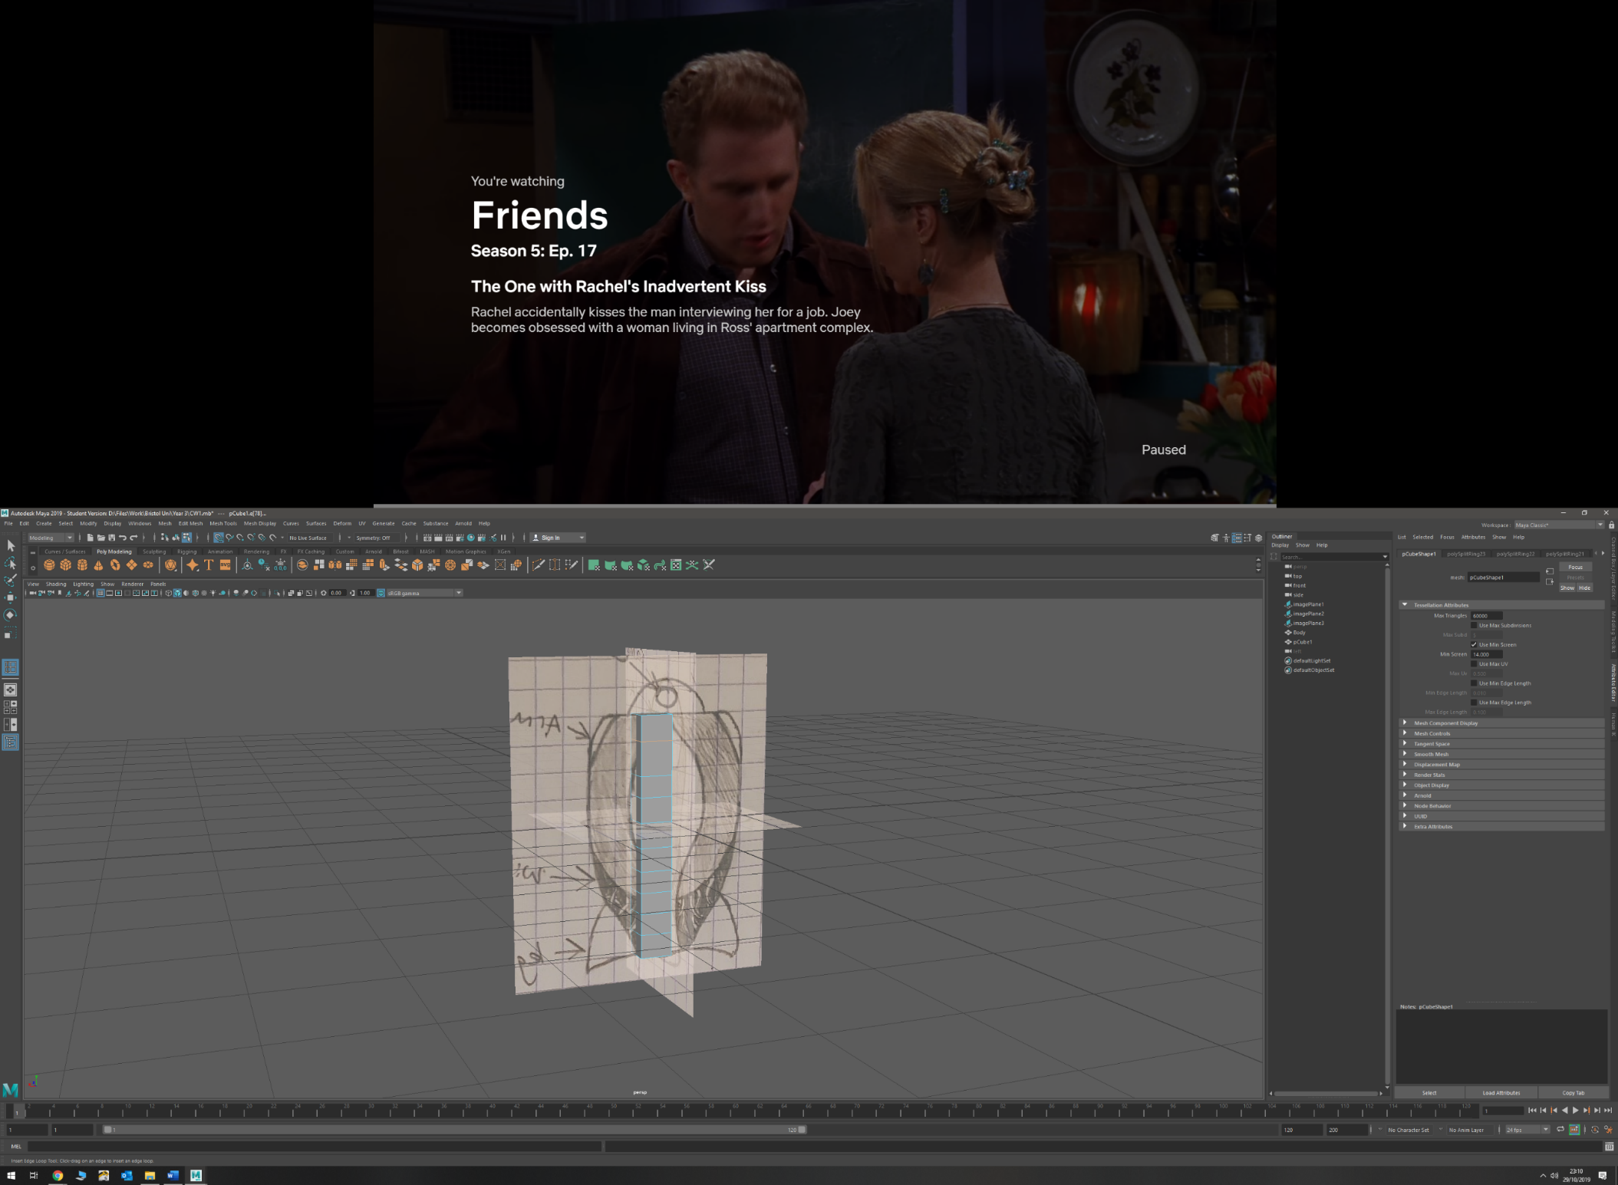

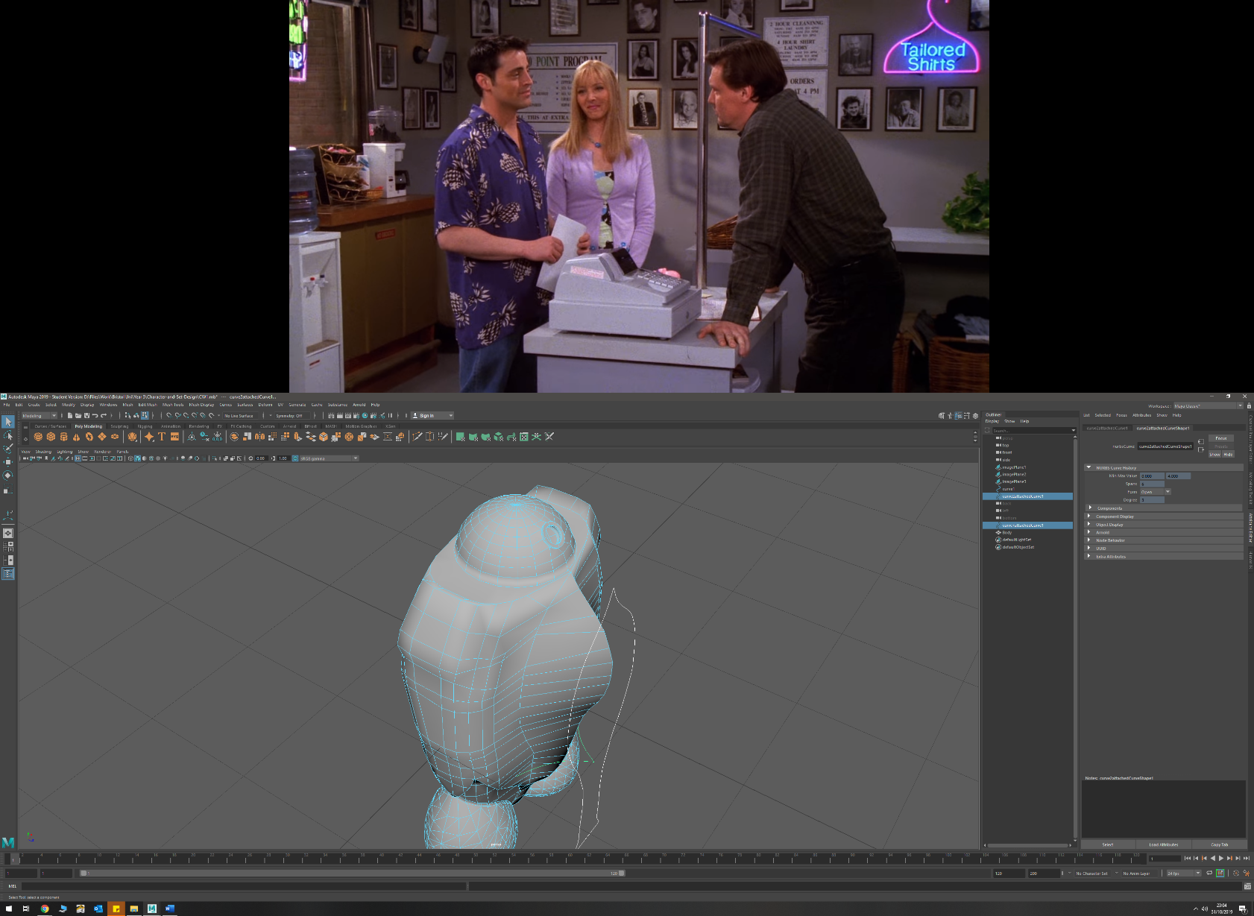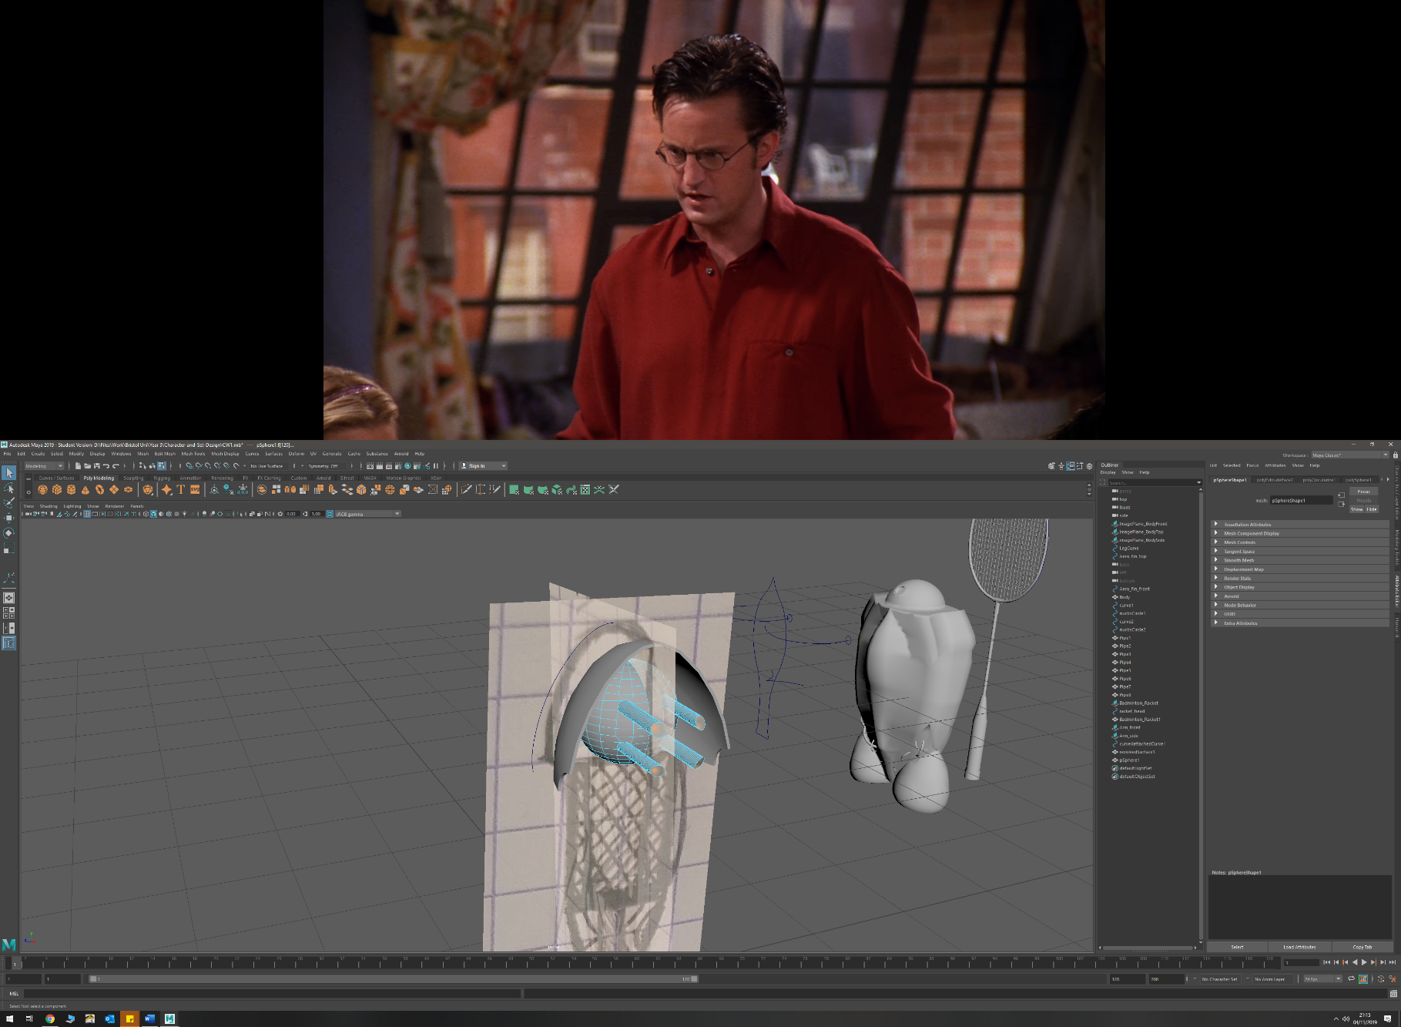

* Extruding faces (outward and inwards)
  + Shoulder mount (outwards) from torso
  + Lower torso detail (inwards) to create depth
  + Forearm (outwards)
  + Leg (upper and lower) (outwards)
  + Arm exoskeleton (outwards) to create thickness and the connecting arms to ring
  + Running blade (outwards) to create thickness
  + Head mount (inwards) to create the mount from original head
  + Badminton racket (faces outwards) to create handle and stem
* Sub-dividing
  + Torso
  + Torso Areo-fin
* Scaling faces and edges (outwards and inwards)
  + Arm (edges and faces outwards) to create forearm fin and taper forearm inwards
  + Leg (upper and lower) (edges inwards, faces outwards) to taper inwards at ends and add detail
  + Badminton racket handle (faces outwards) to widen stem for handle
  + Head mount (inwards)
* Lofting between two curves
  + Arm Exoskeleton
  + Running Blade
* EP curves
  + Areo-fin
  + Running Blades
  + Shoulder pad
* Tracing from imported images with EP curve (real life and sketches)
  + Badminton racket (real life object)
  + Running blade (Personal sketches)
  + Shoulder pad (personal sketches)
* Target Welding
  + Shoulder mounting plate
  + Torso
  + Forearm
* Revolving a profile curve
  + Leg mounts (360 degree)
  + Shoulder Pads (90 degree)
* Bevelling on edges and vertices
  + Torso front and read edges near shoulders
  + Claw end
* Smoothing by subdivision
  + Torso back in recessed detail to match curvature more smoothly
* Boolean union, difference
  + Racket mesh (both)
  + Arm Exoskeleton mesh (both)
  + Leg mounts and torso (union)
  + Arm – to shape upper and lower arm around joint (difference)
  + Leg – to shape upper and lower leg around joint (difference)
* Extruding a NURBS along a curve (with and without twist)
  + Torso pipe details (with twist)
  + Arm wire detail (no twist)
  + Badminton racket head (no twist)
* CV curve
  + Badminton racket head
  + Leg mount
* EP curves
  + Areo-fin
  + Running Blades
  + Shoulder pad
* Separating polygonal faces
  + Aero-fin from torso
  + Shoulder mounts from torso
  + Head from torso
* Attaching two curves (create half of curve then duplicate and attach)
  + Badminton racket
  + Shoulder pad
* Combining Polygons
  + Badminton racket mesh
  + Arm Exoskeleton mesh
* Projection of curve onto surface
  + Aero-fin onto torso
* Tessellation (NURBS to polygon)
  + Leg mounts
  + Badminton Racket
* Mass Duplication
  + Badminton racket mesh
  + Arm Exoskeleton side mesh
* Duplication and inverting scale to flip
  + Arm
  + Leg
* Mirroring
  + Torso

**Appendix**

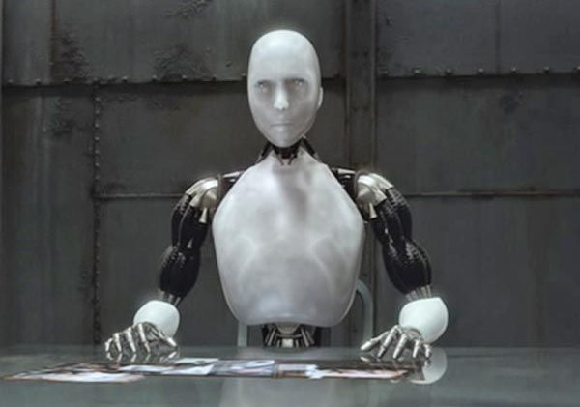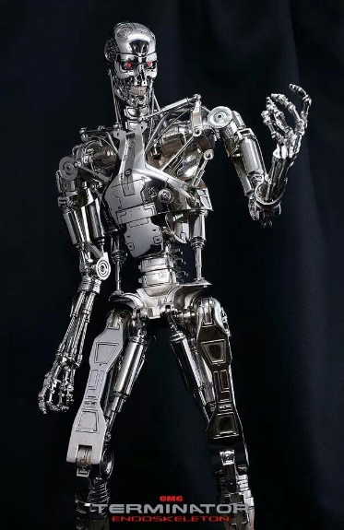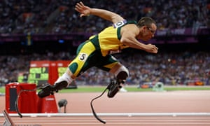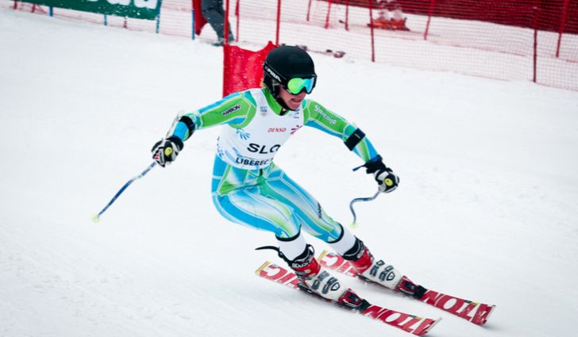**Style Sheet and Visual References**

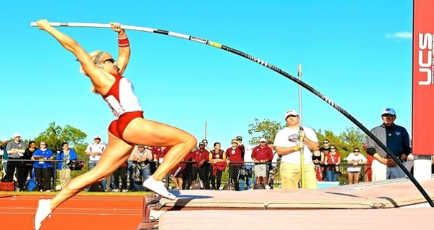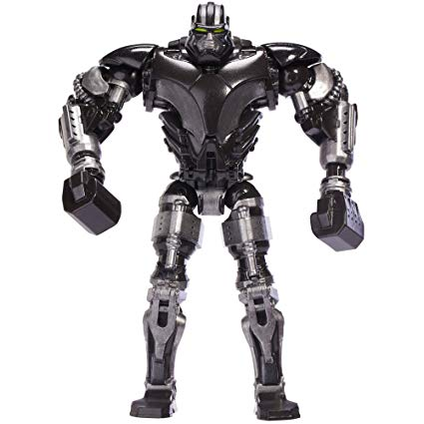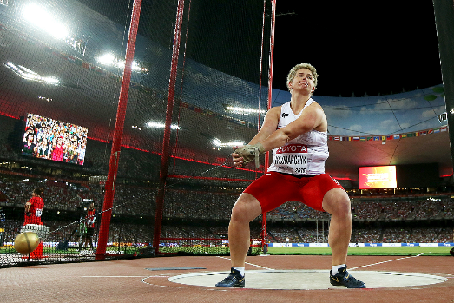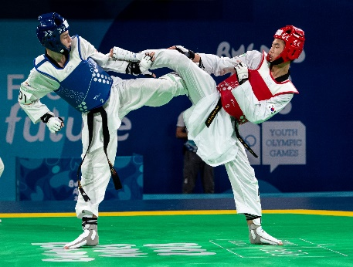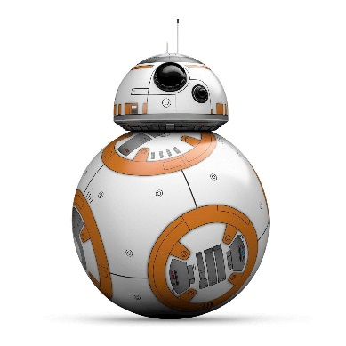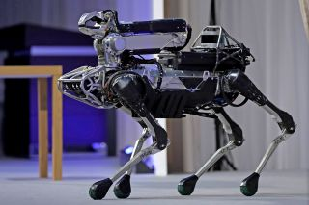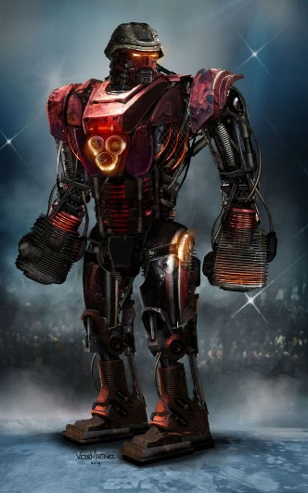

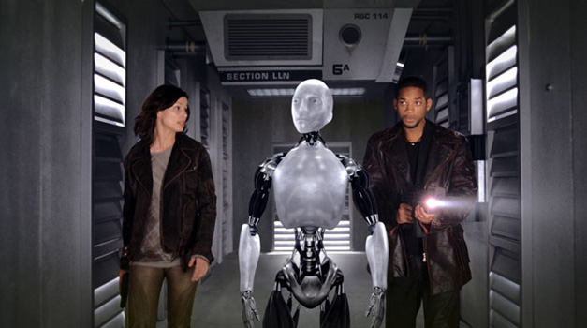

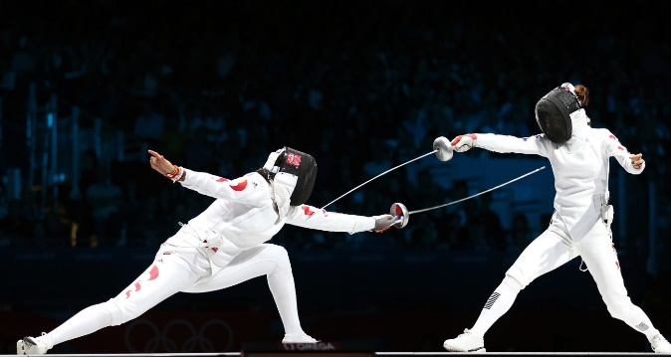

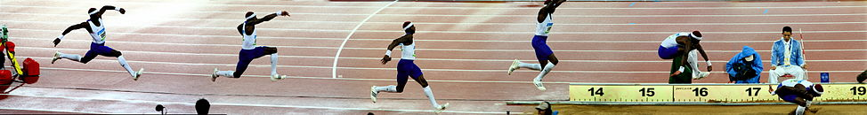

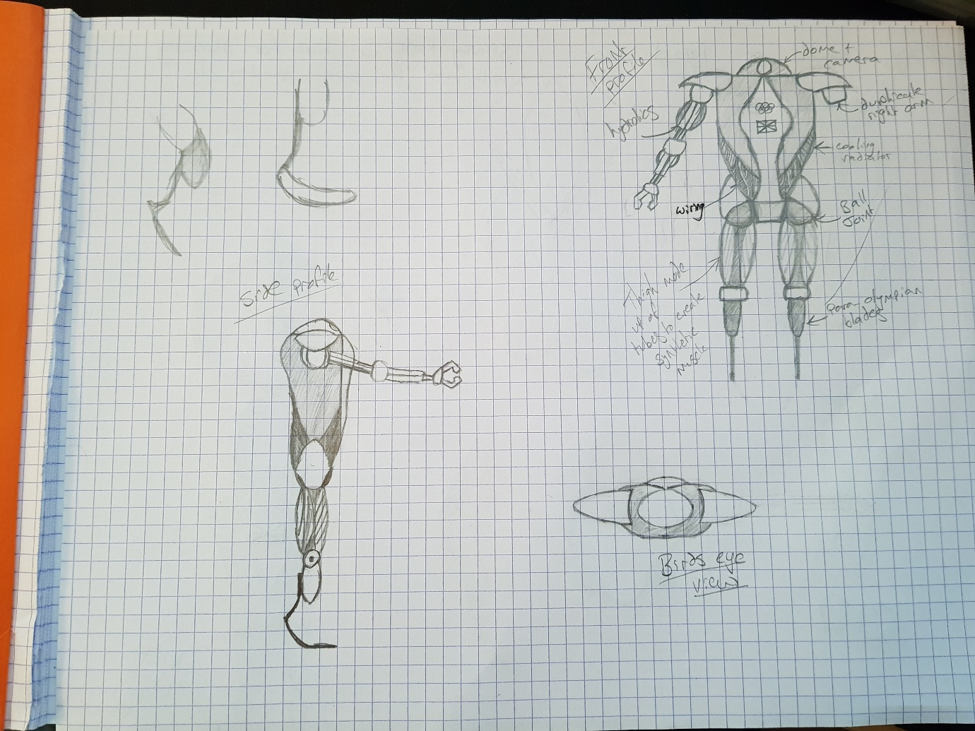**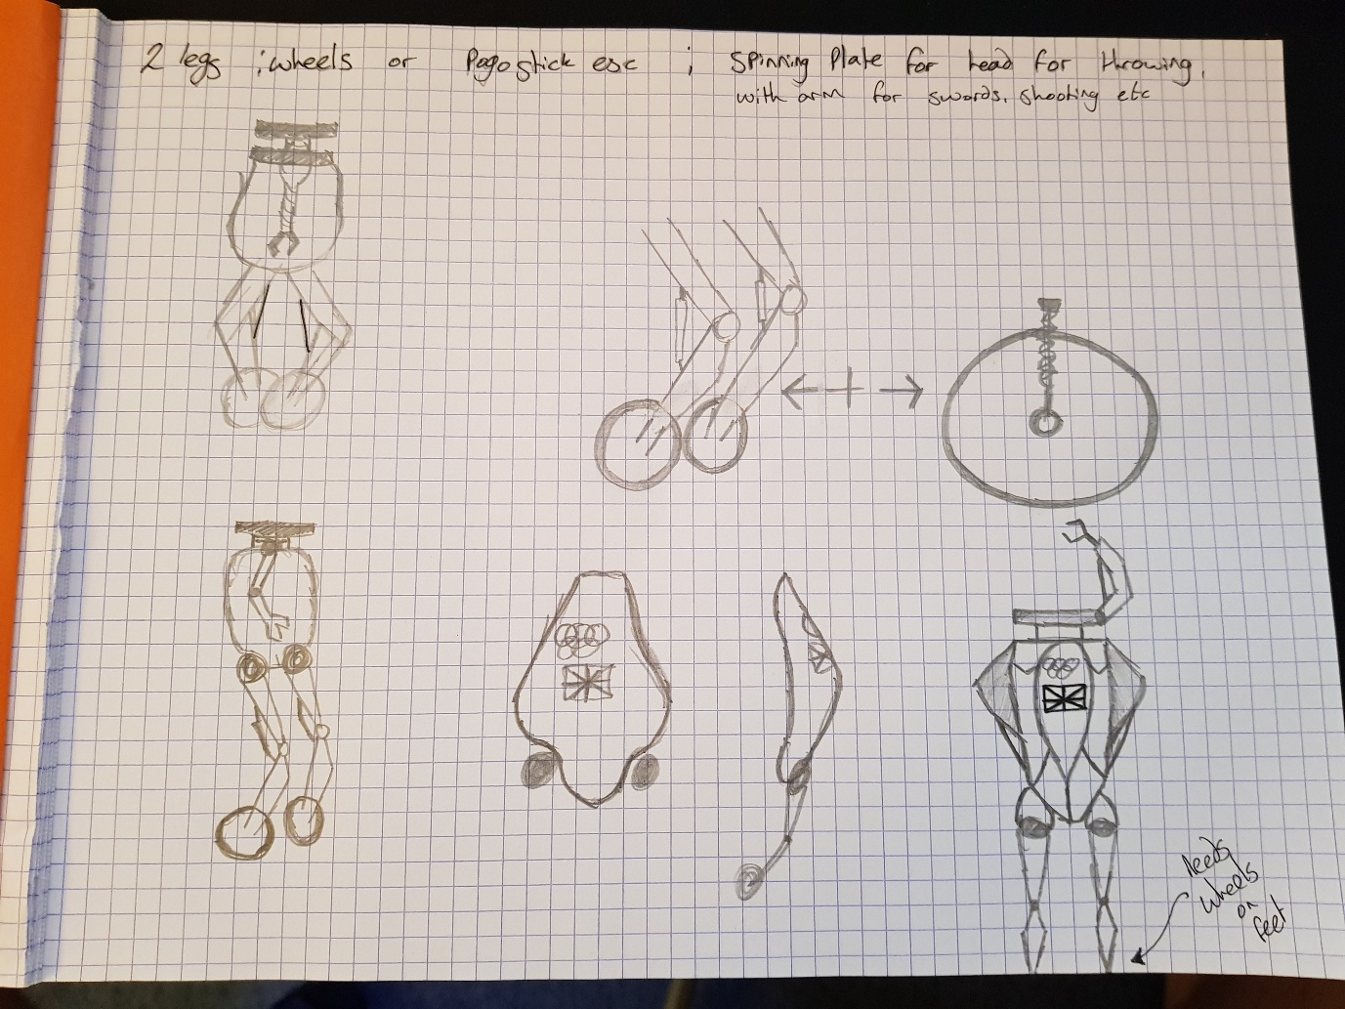Development Drawings**

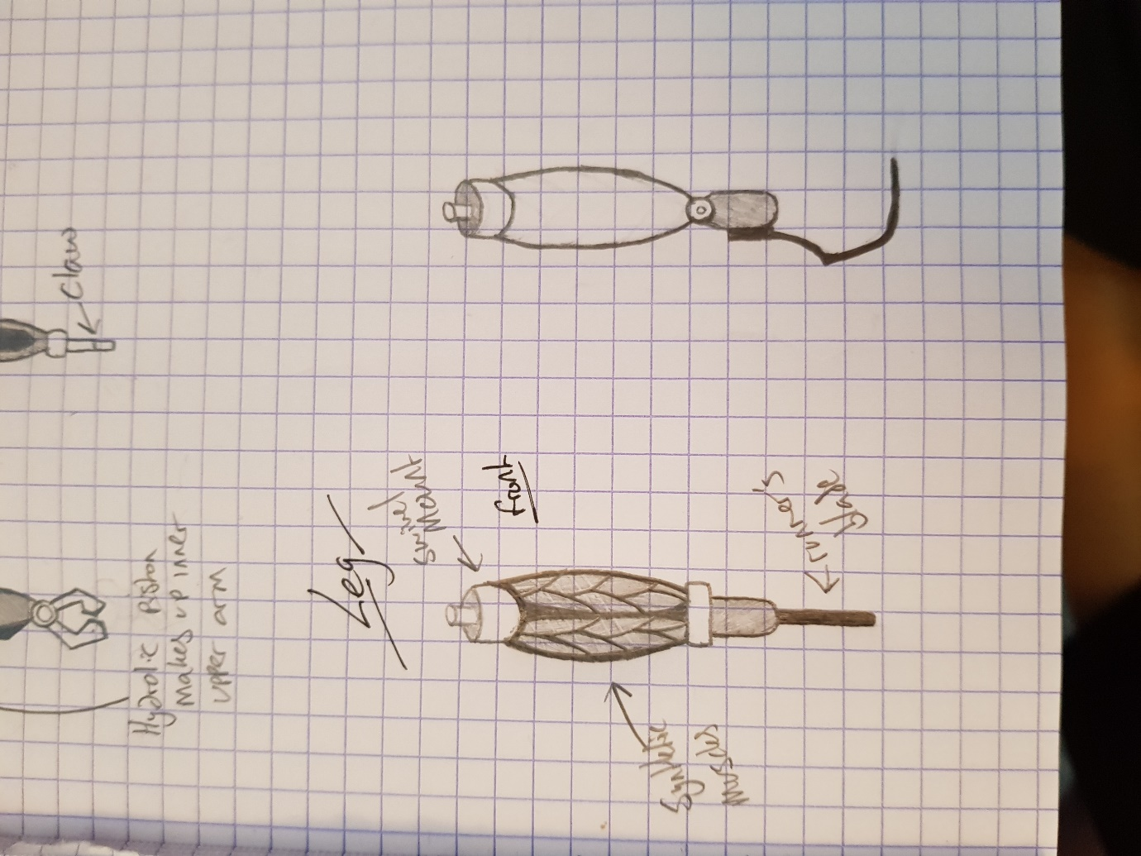**Sketches and Blueprints**

